Ladycross Nature Reserve
Forthcoming Events

Working with People for Nature – Working with Nature for People
Open Day
Saturday September 10th 2016
11am – 4pm
Guided walks through the Nature Reserve
Wood Carving * Country Crafts
Dry Stone Walling Demonstration using Ladycross Stone
Red Squirrels * Bird Boxes * Fire Pits
A guided tour of the Stone Quarry
Membership Benefits of Becoming a Friend of Ladycross
Children’s Activities * Bee Keeping
Refreshments * Eco Loo Opening
Entry £5 per adult (all children free) – free parking
Uneven surfaces please wear suitable footwear
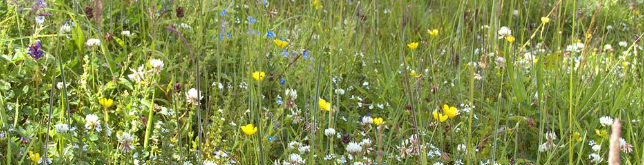
jjewitt245@btinternet.com

